Online Video Rental Store Database Design
Conceptual and Logical Views
Prepared for database design analysis

Introduction
Database design translates multiple user views into one consistent representation of business operations. For this online video rental store, the design must record customers, rentable movie copies, rental invoices, suppliers, and purchase orders. Although the scenario calls the business a streaming store, its copy-level rentals, due dates, returns, and late charges behave like individually controlled rental inventory. The model therefore treats each copy as a distinct rentable unit. PostgreSQL is selected for the logical design because it supports primary keys, foreign keys, composite constraints, precise numeric types, and check constraints.

1. Conceptual View
The conceptual model begins with Movie, which stores the identifying MovieCode, title, and daily late-charge rate. Movie has a one-to-zero-or-many relationship with Copy: one movie can have many physical or licensed copies, while every copy belongs to exactly one movie. Supplier also has a one-to-zero-or-many relationship with Copy, because a supplier can provide many copies and each copy has one supplier. NumberOfCopies is shown as a business measure but is not stored; it is calculated by counting Copy rows for a movie. Removing this derived field prevents update anomalies when inventory changes.

Conceptual ERD
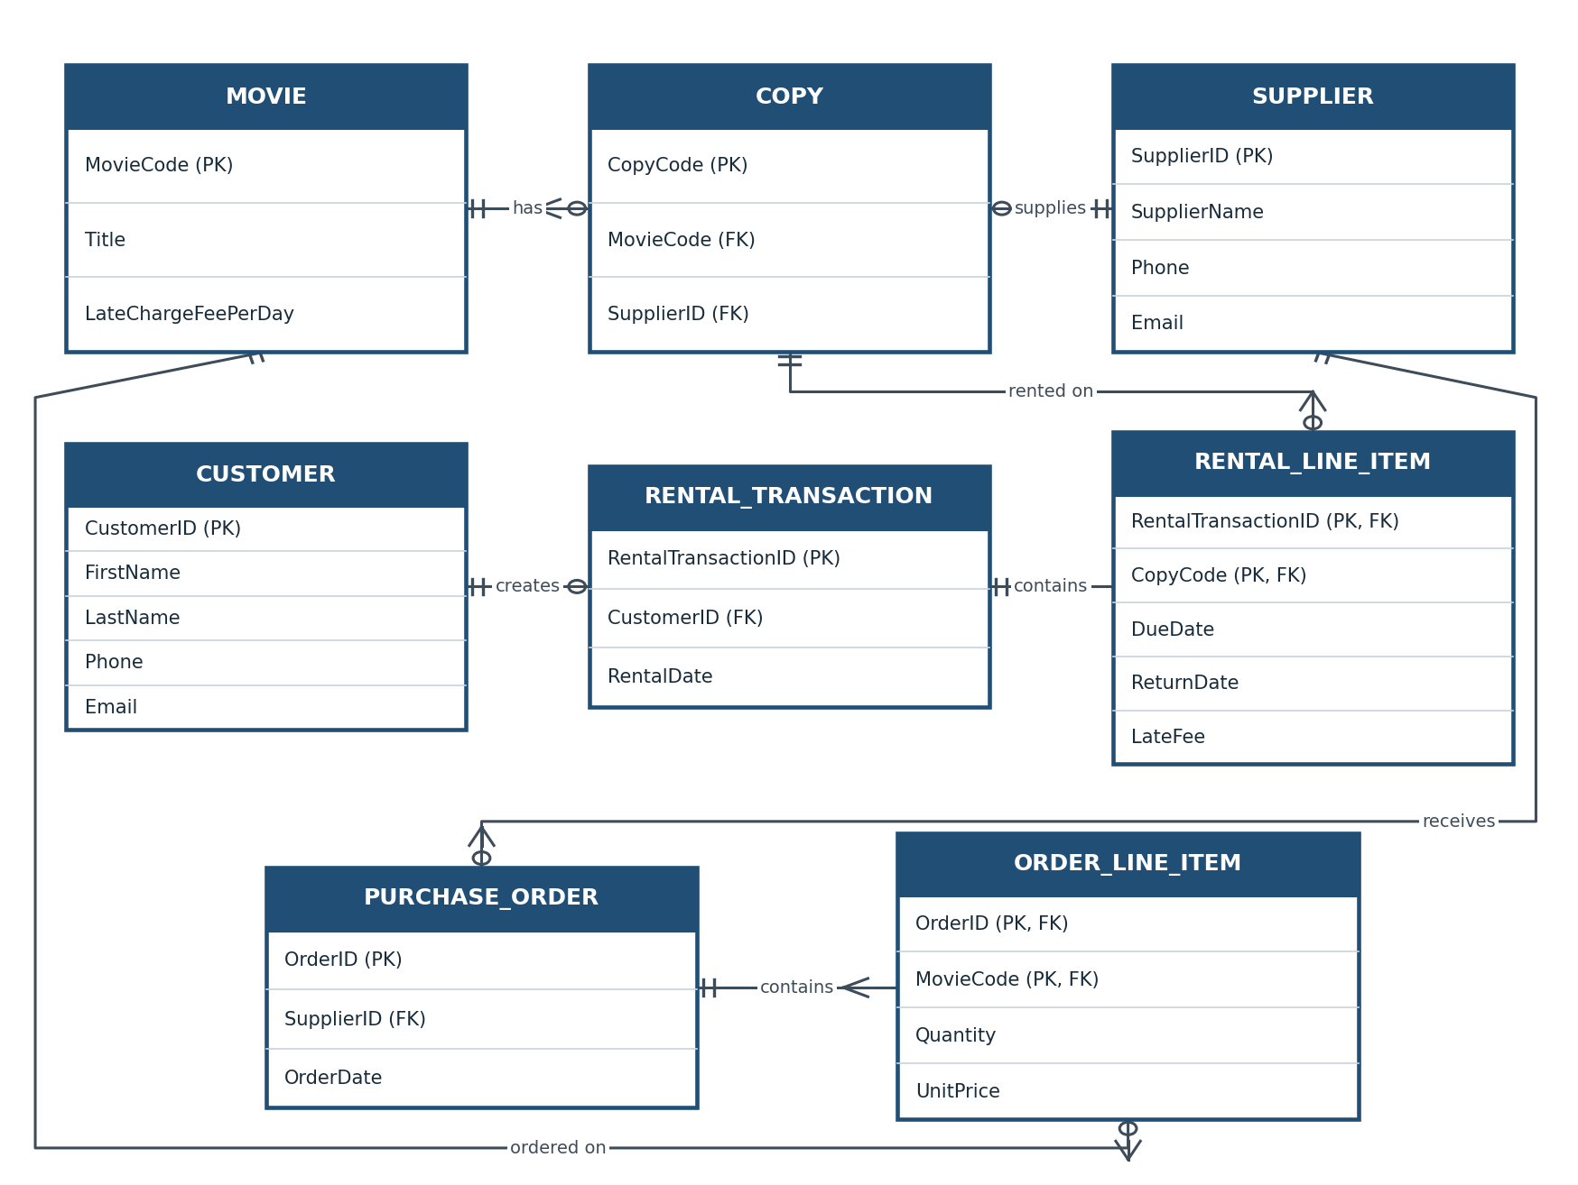
Figure 1. Normalized Crow’s Foot entity relationship diagram.

Customer and Copy have a many-to-many relationship over time. This is resolved through RentalTransaction and RentalLineItem. A customer can create zero or many transactions, but every transaction belongs to one customer and must contain at least one line item. RentalLineItem uses the composite primary key RentalTransactionID plus CopyCode, allowing one invoice to contain multiple copies while preventing the same copy from appearing twice on that invoice. DueDate, ReturnDate, and LateFee belong to the line item because copies on one transaction can have different due or return outcomes. The transaction header therefore stores only RentalDate.
Supplier orders are modeled similarly. Supplier has many PurchaseOrder records, and each order contains one or more OrderLineItem records. An order line identifies a movie title, quantity, and unit price. It references MovieCode rather than CopyCode because individual copy identifiers are assigned after ordered units are received. PurchaseOrder is used instead of Order because ORDER is a reserved SQL keyword.

Normalization Validation
The relations satisfy first normal form because attributes are atomic; general contact fields are divided into phone and email, and customer name is divided into first and last name. They satisfy second normal form because every non-key attribute in a composite-key line table depends on the complete key. They satisfy third normal form because non-key attributes do not depend on other non-key attributes. For example, supplier details are stored only in Supplier, and movie details are not repeated in Copy or an order line. LateFee may be calculated, but retaining it is reasonable as the final assessed historical charge.

2. Logical View
The ERD translates into the PostgreSQL schema below. Integer identity columns generate unique transaction, customer, supplier, and order identifiers. MovieCode and CopyCode may instead use store-assigned integer codes. Foreign keys enforce all parent-child relationships. NOT NULL constraints protect required data; UNIQUE constraints prevent duplicate customer and supplier email addresses; and CHECK constraints reject negative fees, prices, or quantities. ReturnDate remains nullable until a copy is returned. Referential actions should normally restrict deletion of referenced history, while an application transaction should insert every invoice header and its line items atomically.
Table | Columns and constraints
MOVIE | MovieCode PK; Title; LateChargeFeePerDay ≥ 0
COPY | CopyCode PK; MovieCode FK → MOVIE; SupplierID FK → SUPPLIER
CUSTOMER | CustomerID PK; FirstName; LastName; Phone; Email UNIQUE
RENTAL_TRANSACTION | RentalTransactionID PK; CustomerID FK → CUSTOMER; RentalDate
RENTAL_LINE_ITEM | RentalTransactionID PK/FK; CopyCode PK/FK; DueDate; ReturnDate NULL; LateFee ≥ 0
SUPPLIER | SupplierID PK; SupplierName; Phone; Email UNIQUE
PURCHASE_ORDER | OrderID PK; SupplierID FK → SUPPLIER; OrderDate
ORDER_LINE_ITEM | OrderID PK/FK; MovieCode PK/FK; Quantity > 0; UnitPrice ≥ 0

Conclusion
This design captures both customer rentals and vendor purchasing without repeating groups or unresolved many-to-many relationships. It also preserves operational history while allowing inventory totals and overdue charges to be reported accurately. The separation of headers from line items supports invoices containing multiple copies or movie titles and gives end users a dependable view of the store’s rental and supply activities.
Narrative word count: approximately 600 words (excluding diagram labels and schema table).

